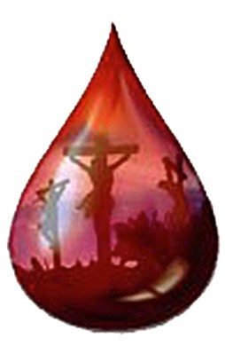
His Blood to Pay My Debts

O Lord of grace.
The world is before me this day –
full of promise and potential,
filled with opportunities to be of service,
a day to shine glory and share good news.
But . . .

I am weak and fearful and full of sin.
If left to the treachery of my own heart,
I will shame Your divine Name.
If I venture forth alone I will fall short,
so give me the fullness of Your Son.
I plead His blood to pay my debts.

Accept His worthiness for my unworthiness,
His sinlessness for my transgressions,
His purity for my uncleanness,
His sincerity for my guile,
His truth for my many deceits,
His humility for my pride,
His constancy for my backslidings,
His love for my hatred,
His faithfulness for my treachery,
His obedience for my lawlessness,
His glory for my shame,
His devotedness for my waywardness,
His holy life for my unchaste ways,
His righteousness for my dead works,
His death for my life.

On my own, I am limp,
but on my Beloved’s arm I am firm as the ancient mountains.
So be my arm of support,
my strength to stand,
my light to see,
my feet to run,
my shield to protect,
my sword to repel,
my sun to warm.
To enrich me will not diminish Your fullness.

- The Valley of Vision, “God All-Sufficient,” p. 155.

